

Computer Network Lab

Project Report

Supervised by
Miss Sobia Asher

Computer Network Lab Project
BS Computer Science, Batch 2022F

Company Network Design & Implementation Using Cisco Packet Tracer

Group Members:

Name | Roll Number
Saad Ali | 2022F-BCS-162
Muzamil | 2022F-BCS-316
Muhammad Faisal | 2022F-BCS-152
Mudassir Alam | 2022F-BCS-151

Supervisor

Project Report

Introduction
In today's fast-paced business environment, a well-designed network infrastructure is crucial for the seamless operation of any organization. This project focuses on designing a robust, scalable, and secure network for a trading floor support center that is expanding to a new building. The new building will accommodate 600 staff members across three floors, each housing two departments. The network design must meet the current business needs while being future-proofed to accommodate potential growth and changes.

Project Overview
The project involves designing a logical network architecture for a new building with three floors, each housing two departments. The network must support 600 users and 12 server room devices, with specific requirements for each department, including wireless networking, VLAN segmentation, and dynamic IP addressing. The network design must also incorporate redundancy, security, and efficient routing mechanisms to ensure high availability and performance.

Key Components:
- Three Floors:
  - First Floor: Sales & Marketing (120 users), Human Resource & Logistics (120 users)
  - Second Floor: Finance & Accounts (120 users), Administration & Public Relations (120 users)
  - Third Floor: ICT (120 users), Server Room (12 devices)

- Network Requirements:
  - Hierarchical network design with redundancy at every layer.
  - Wireless networking for each department.
  - VLAN segmentation and subnetting for each department.
  - Dynamic IP addressing via DHCP for all devices except server room devices.
  - Inter-VLAN routing using multilayer switches.
  - OSPF as the routing protocol.
  - SSH for remote access to routers and switches.
  - Port security for the Finance & Accounts department.
  - PAT with ACLs for internet access.
  - Connectivity to two ISPs for redundancy.

Project Objective
The primary objective of this project is to design and implement a logical network architecture that meets the current and future needs of the organization. The network design should ensure high availability, security, scalability, and efficient routing, while also providing a seamless user experience across all departments.

Features

1. Hierarchical Network Design
The network is designed using a hierarchical model, which includes:
- Core Layer: High-performance routers (R1 and R2) providing redundancy and connectivity to ISPs.
- Distribution Layer: Multilayer switches (MLS-W1 and MLS-W2) providing inter-VLAN routing and redundancy.
- Access Layer: Access switches providing connectivity to end-user devices.

2. Redundancy
- Router Redundancy: Two routers (R1 and R2) are used to provide redundancy at the core layer.
- Switch Redundancy: Two multilayer switches (MLS-W1 and MLS-W2) are used to provide redundancy at the distribution layer.
- ISP Redundancy: Connectivity to two ISPs to ensure internet redundancy.

3. VLAN Segmentation
- Each department is assigned to a different VLAN:
  - VLAN 10: Sales & Marketing
  - VLAN 20: Human Resource & Logistics
  - VLAN 30: Finance & Accounts
  - VLAN 40: Administration & Public Relations
  - VLAN 50: ICT
  - VLAN 60: Server Room

4. Subnetting
- The base network 172.16.1.0 is subnetted to provide sufficient IP addresses for each department:
  - First Floor:
    - Sales & Marketing: 172.16.1.0/25
    - Human Resource & Logistics: 172.16.1.128/25
  - Second Floor:
    - Finance & Accounts: 172.16.2.0/25
    - Administration & Public Relations: 172.16.2.128/25
  - Third Floor:
    - ICT: 172.16.3.0/25
    - Server Room: 172.16.3.128/28

5. Dynamic IP Addressing
- DHCP servers located in the server room will dynamically assign IP addresses to all devices except those in the server room, which will have static IP addresses.

6. Inter-VLAN Routing
- Multilayer switches (MLS-W1 and MLS-W2) are configured for inter-VLAN routing, allowing devices in different VLANs to communicate with each other.

7. Routing Protocol
- OSPF (Open Shortest Path First) is used as the routing protocol to advertise routes between routers and multilayer switches.

8. SSH for Remote Access
- SSH (Secure Shell) is configured on all routers and multilayer switches to provide secure remote access.

9. Port Security
- Port security is configured for the Finance & Accounts department to allow only one device to connect to a switch port, using a sticky method to obtain MAC addresses and shutting down the port in case of violation.

10. PAT with ACLs
- PAT (Port Address Translation) is configured to use the outbound router interface IPv4 address, with necessary ACL rules to control internet access.

11. Wireless Networking
- Each department has a wireless network configured to provide wireless connectivity to users.

Technologies Used
- Cisco Packet Tracer: For designing and simulating the network topology.
- Routers: Cisco routers (R1 and R2) for core layer redundancy and ISP connectivity.
- Multilayer Switches: Cisco multilayer switches (MLS-W1 and MLS-W2) for distribution layer redundancy and inter-VLAN routing.
- Access Switches: Cisco access switches for connecting end-user devices.
- Wireless Access Points: For providing wireless networking in each department.
- Protocols:
  - OSPF: For routing between routers and switches.
  - SSH: For secure remote access to routers and switches.
  - PAT: For internet access translation.
  - DHCP: For dynamic IP address allocation.
  - VLANs: For network segmentation.

Conclusion
The designed network architecture provides a robust, scalable, and secure solution for the organization's expansion to a new building. The hierarchical model with redundancy at every layer ensures high availability and performance, while VLAN segmentation and subnetting provide efficient network management. The use of OSPF, SSH, and PAT ensures efficient routing, secure remote access, and controlled internet access. The network design is future-proofed to accommodate potential growth and changes, making it a reliable foundation for the organization's continued success.

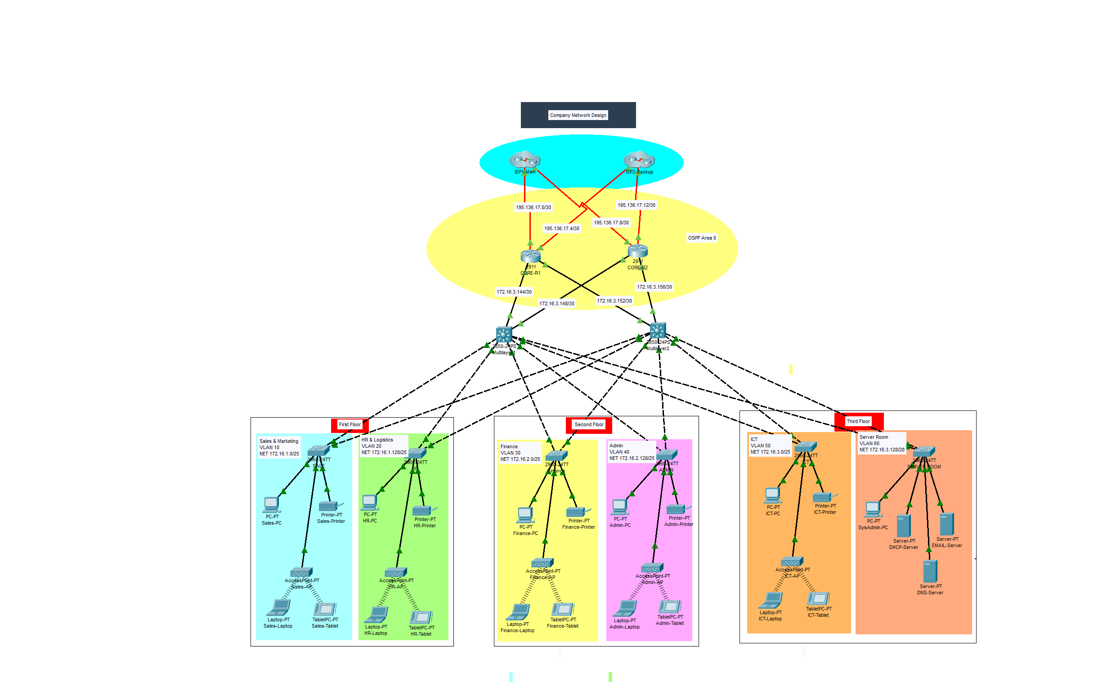

IP Addressing
Base Network: 172.16.1.0
First Floor
Department | Network Address | Subnet Mask | Host Address Range | Broadcast Address
Sales & Marketing | 172.16.1.0 | 255.255.255.128/25 | 172.16.1.1 to  172.16.1.126 | 172.16.1.127
HR and Logistics | 172.16.1.128 | 255.255.255.128/25 | 172.16.1.129 to 172.16.1.254 | 172.16.1.255

Second Floor
Department | Network Address | Subnet Mask | Host Address Range | Broadcast Address
Finance & Accounts | 172.16.2.0 | 255.255.255.128/25 | 172.16.2.1 to  172.16.2.126 | 172.16.2.127
Admin & Public Relations | 172.16.2.128 | 255.255.255.128/25 | 172.16.2.129 to 172.16.2.254 | 172.16.2.255

Third Floor
Department | Network Address | Subnet Mask | Host Address Range | Broadcast Address
ICT | 172.16.3.0 | 255.255.255.128/25 | 172.16.3.1 to  172.16.3.126 | 172.16.3.127
Server Room | 172.16.3.128 | 255.255.255.240/25 | 172.16.3.129 to 172.16.1.142 | 172.16.3.143

Between the Routers and Layer-3 Switches
No. | Network Address | Subnet Mask | Host Address Range | Broadcast Address
R1-MLSW1 | 172.16.3.144 | 255.255.255.252 | 172.16.3.145 to  172.16.3.147 | 172.16.3.147
R1-MLSW2 | 172.16.3.148 | 255.255.255.252 | 172.16.3.149 to  172.16.3.151 | 172.16.3.151
R2-MLSW1 | 172.16.3.152 | 255.255.255.252 | 172.16.3.153 to  172.16.3.155 | 172.16.3.155
R2-MLSW2 | 172.16.3.156 | 255.255.255.252 | 172.16.3.157 to 172.16.3.158 | 172.16.3.159

Between the Routers and ISPs
Public IP addresses 195.136.17.0/30, 195.136.17.4/30, 195.136.17.8/30 and 195.136.17.12/30

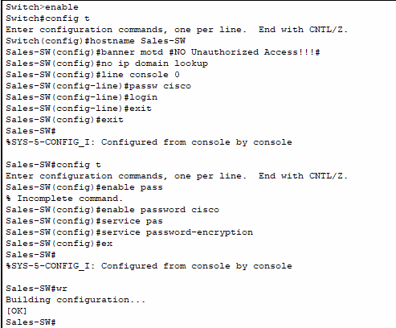
Sales Switch

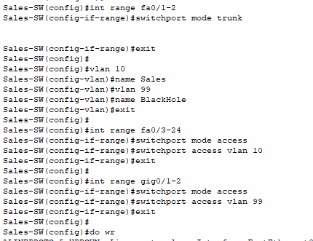

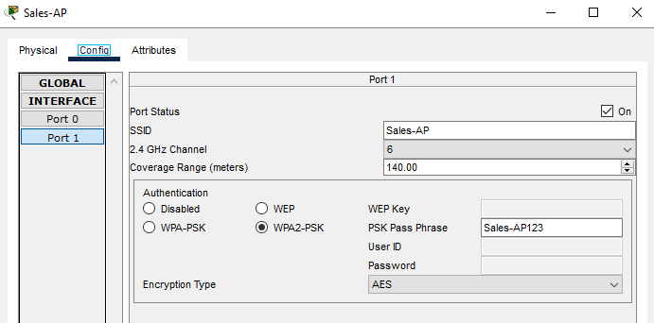
Sales Access Point

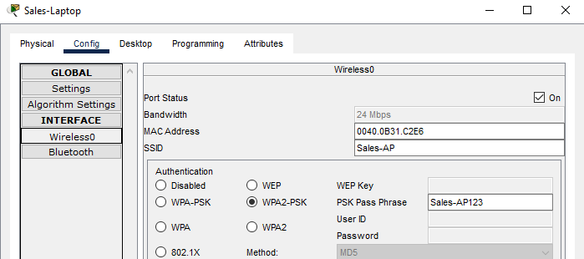
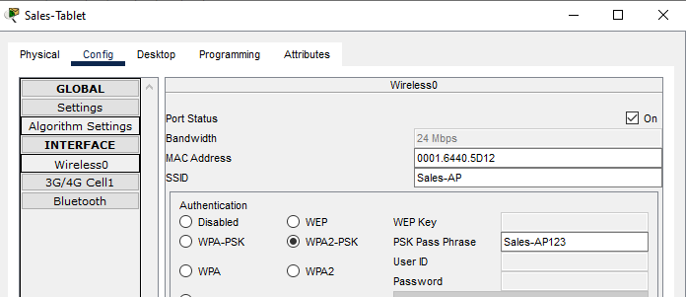
Sales Tablet & Laptop

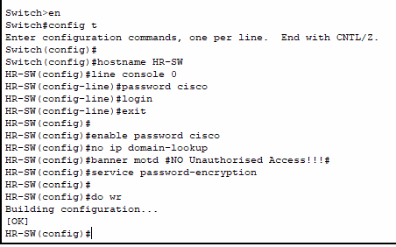
HR switch

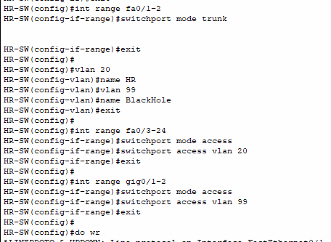

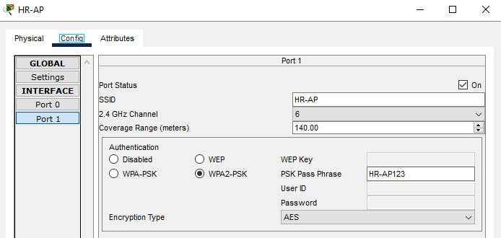
HR access point

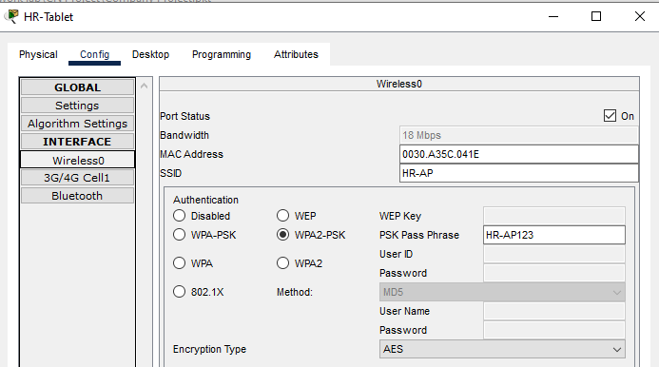
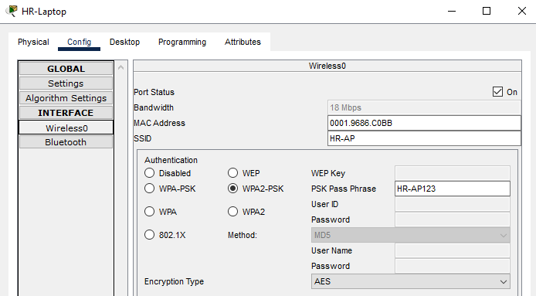
HR Tablet & Laptop

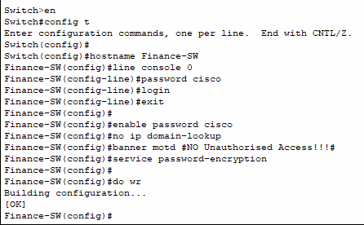
Finance Switch

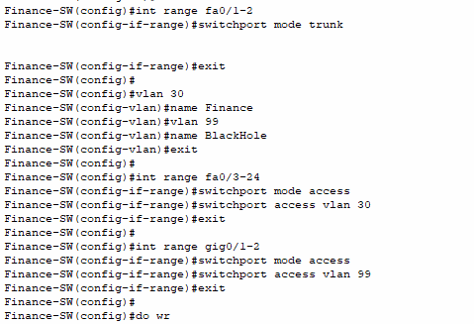

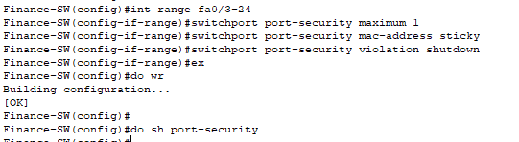

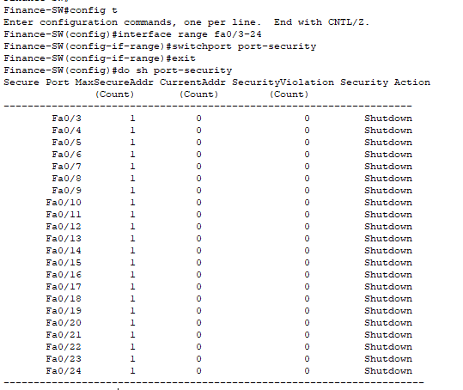

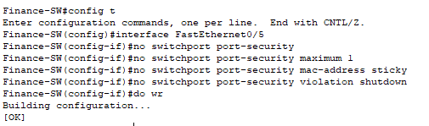

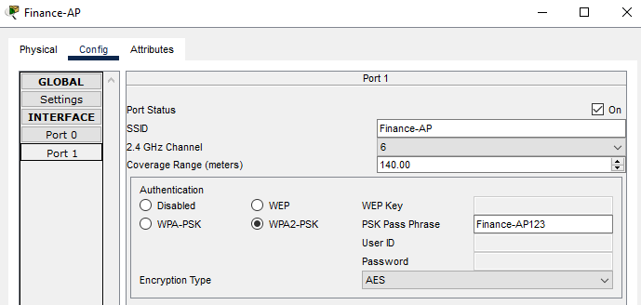
Finance access point

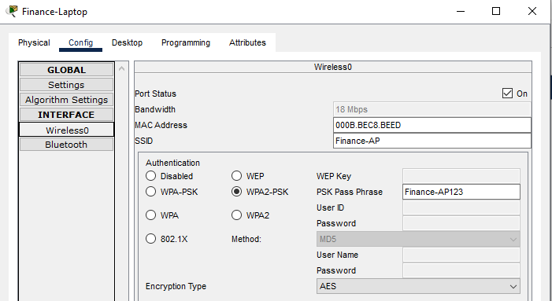
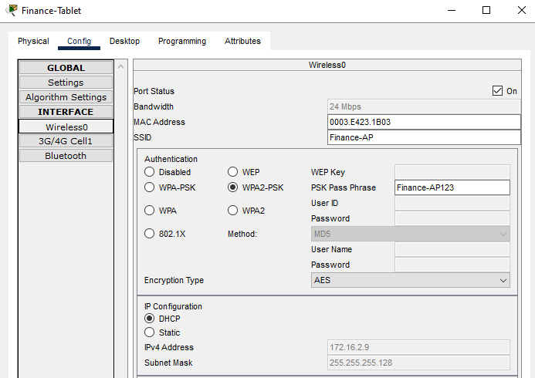
Finance Tablet & Laptop

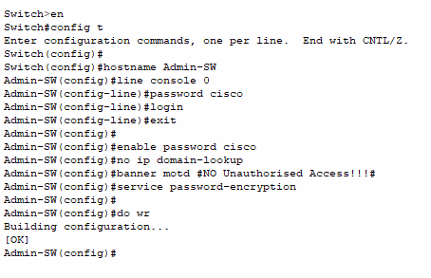
Admin

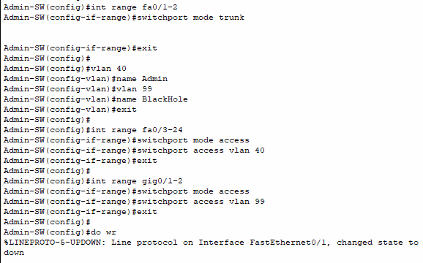

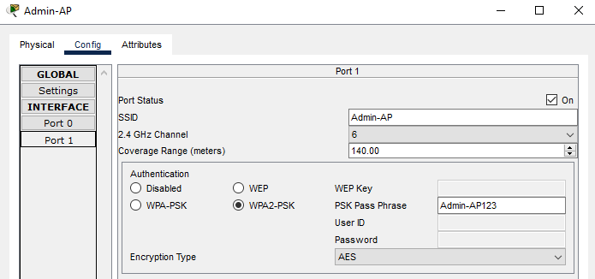
Admin access point

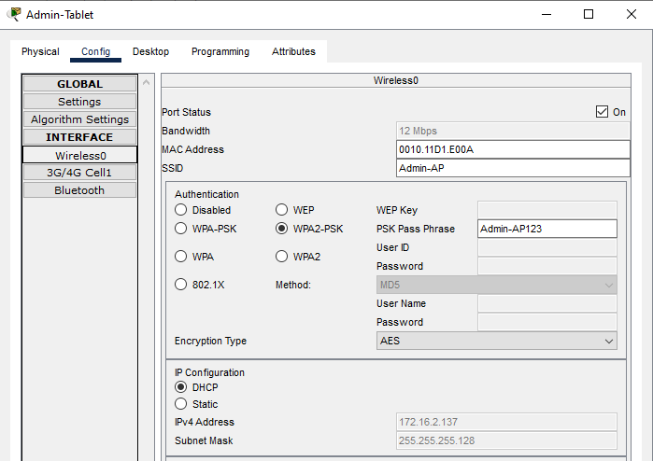
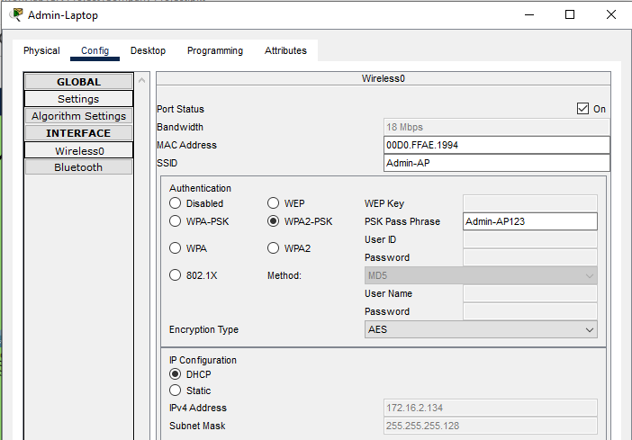
Admin Tablet & Laptop

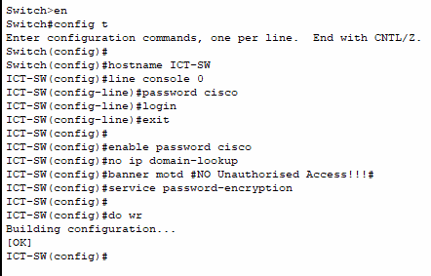
ICT Switch

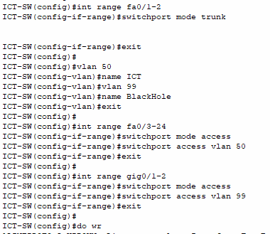

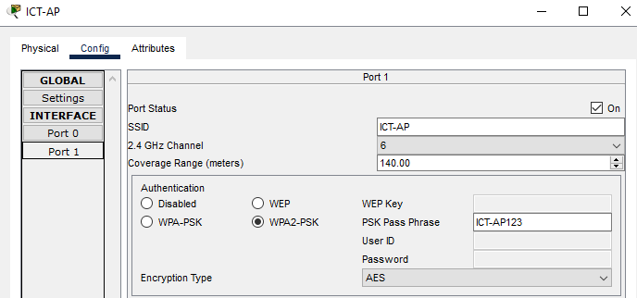
ICT Access Point

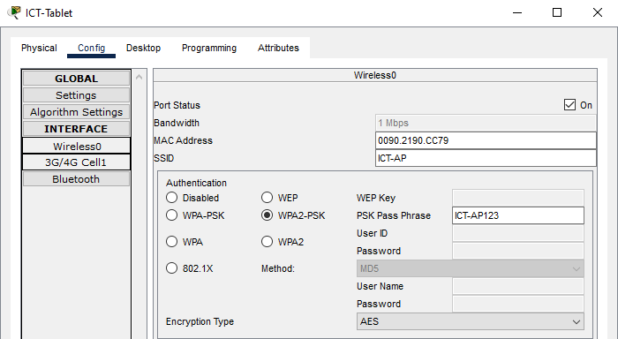
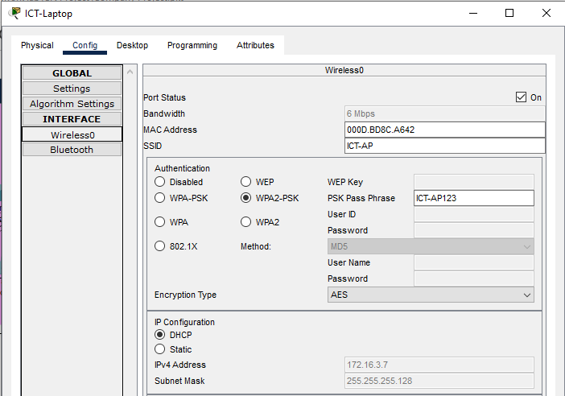
ICT Tablet & Laptop

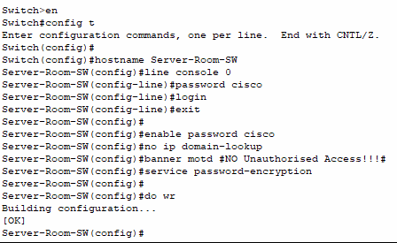
Server Room Switch

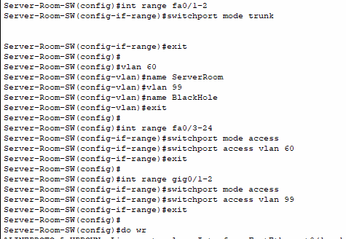

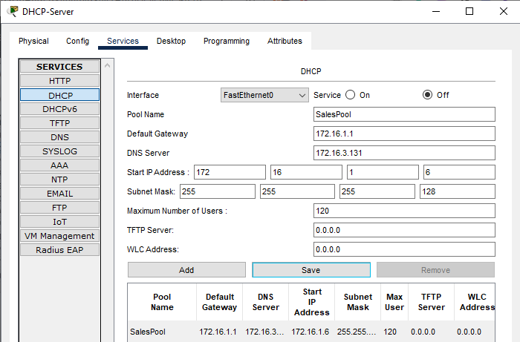
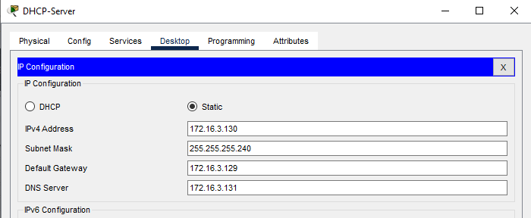
DHCP Server

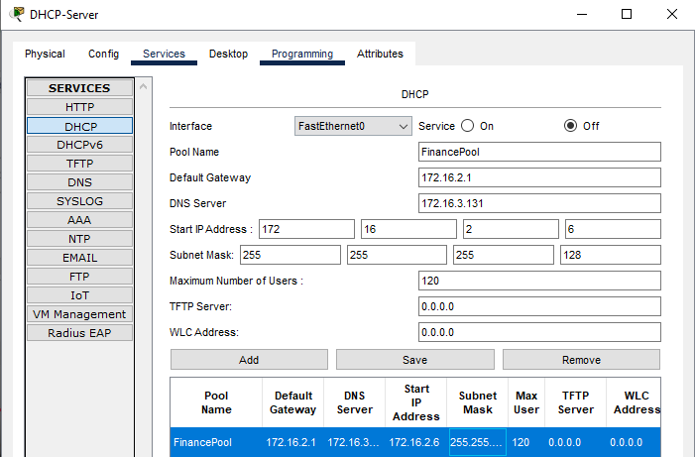
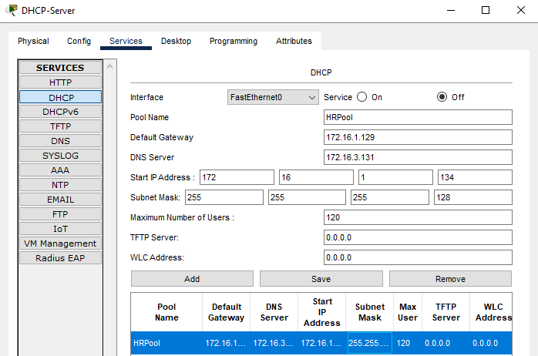

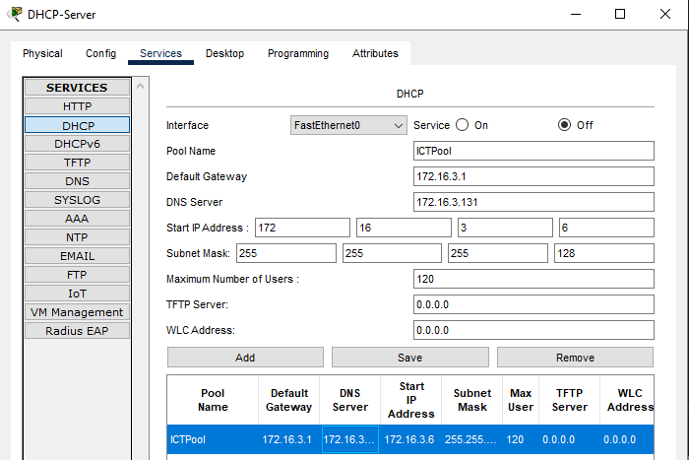
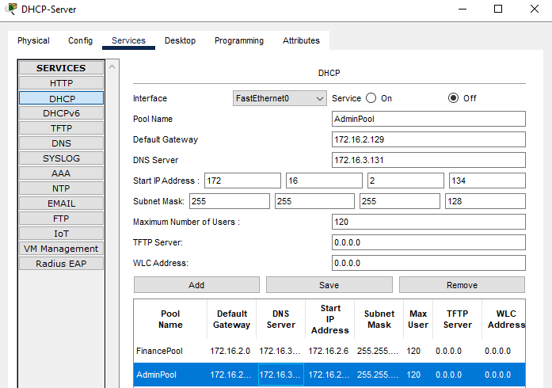

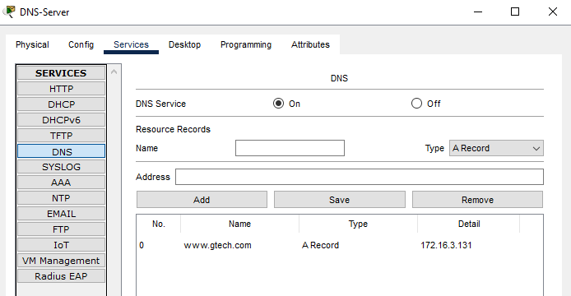
DNS-Server
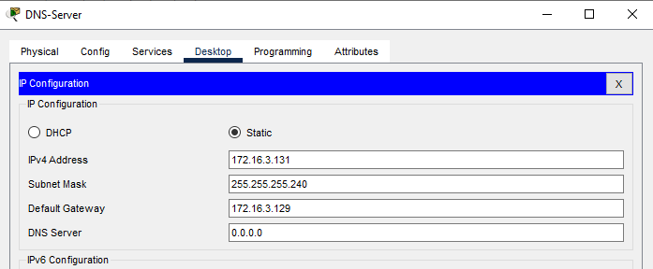
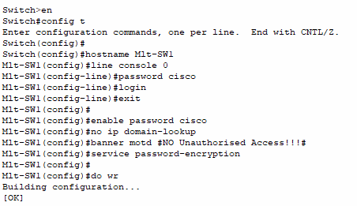
MultiLayer Switch-1

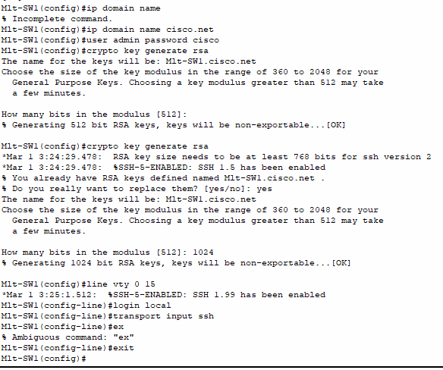

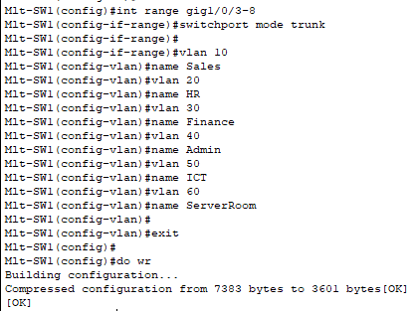
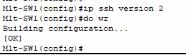

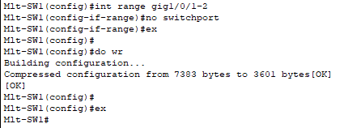

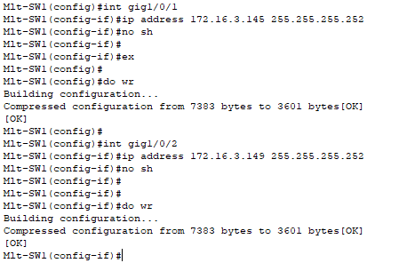

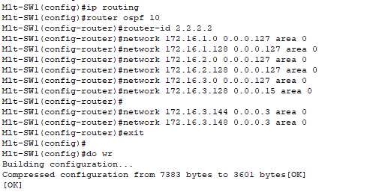

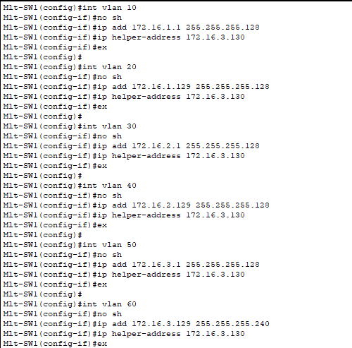

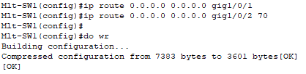

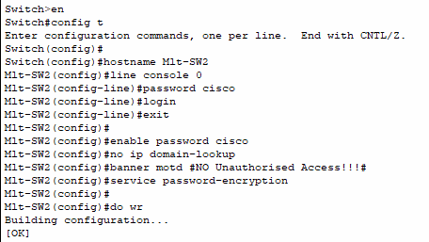
MultiLayer Switch-2

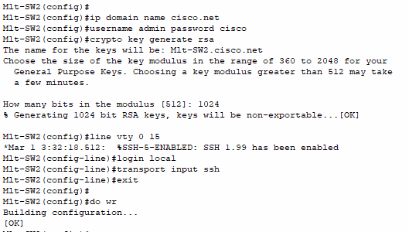

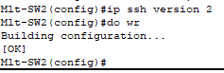
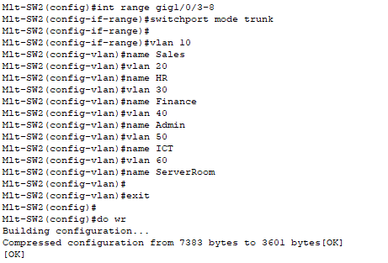

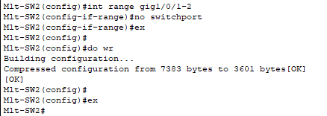

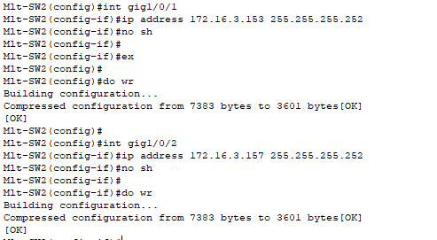

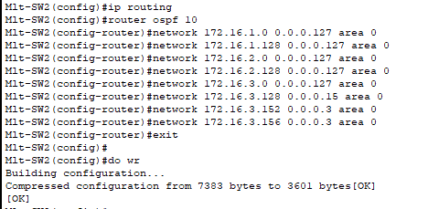

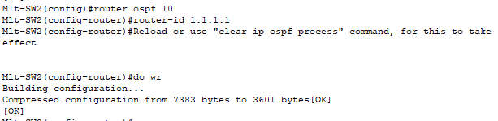
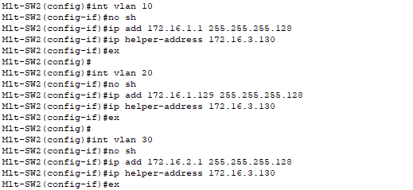

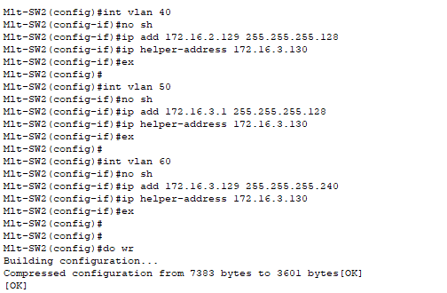

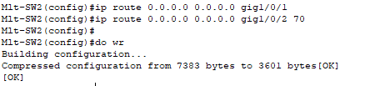

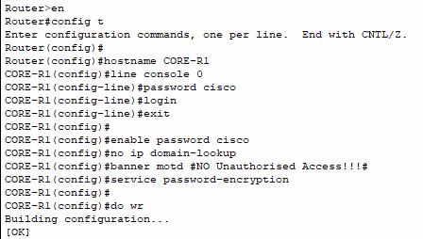
Core router 1

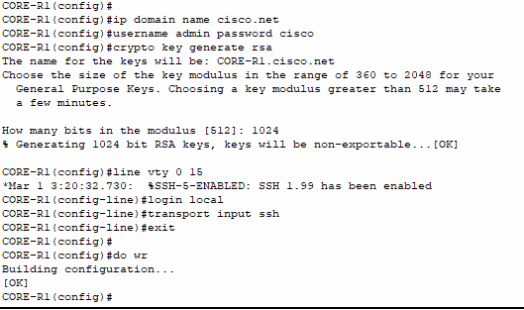

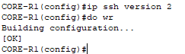
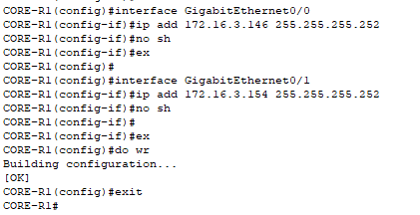

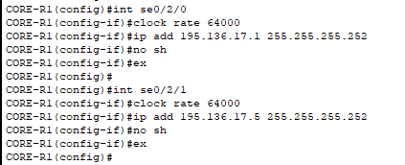

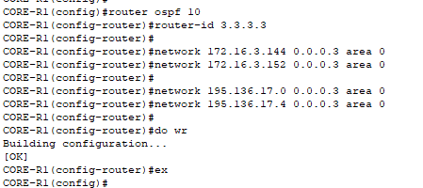

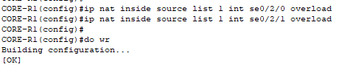
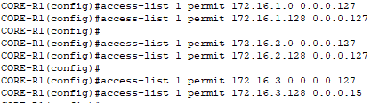

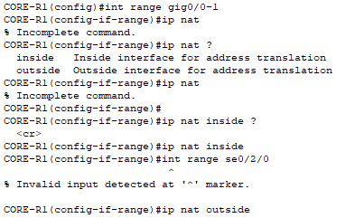

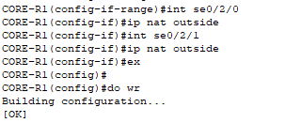

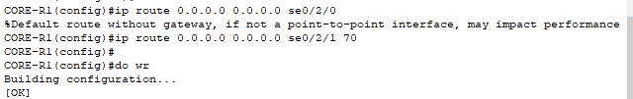

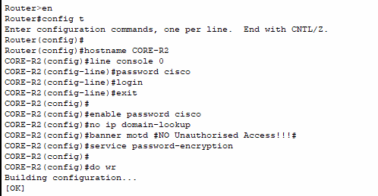
Core router 2

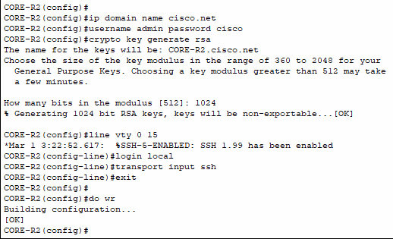

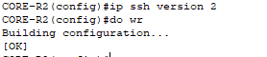
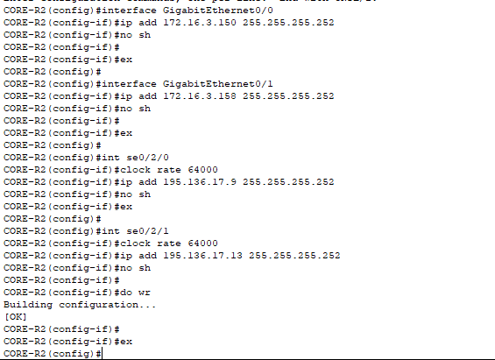

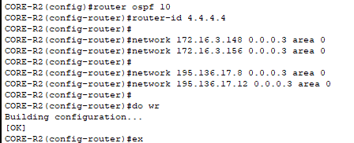

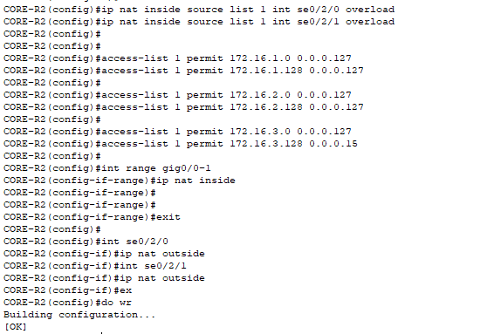

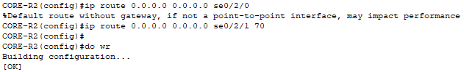

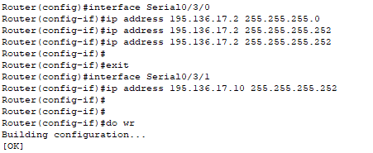
ISP Router-1

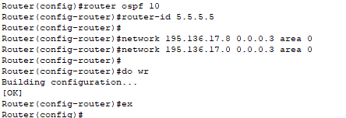

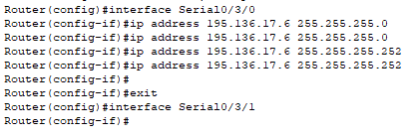
ISP Router-2

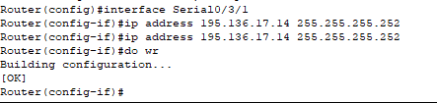

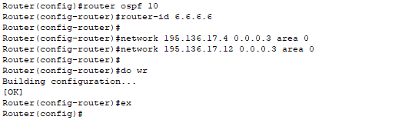

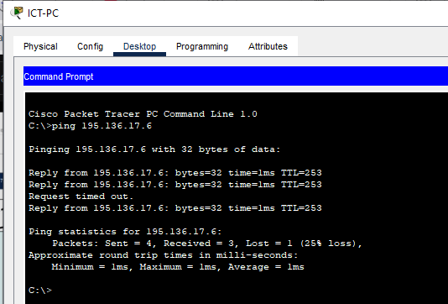
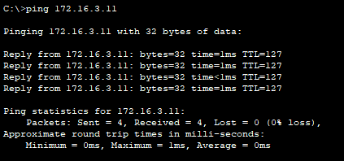
Ping Tests

SSH Access
